CHAPTER 1
COMPANY
  - Company Profile
EduPhoenix Solutions is a dynamic and innovative company dedicated to providing cutting-edge solutions in the field of education technology. Established with a vision to revolutionize learning experiences, EduPhoenix Solutions offers a comprehensive range of products and services tailored to meet the evolving needs of educational institutions, students, and educators.
At EduPhoenix Solutions, we leverage the latest advancements in technology to develop intuitive and interactive educational platforms, tools, and resources. Our team of experts is committed to designing and delivering solutions that enhance teaching effectiveness, engage learners, and foster academic success.
From e-learning platforms and virtual classrooms to customized educational software and mobile applications, EduPhoenix Solutions offers a diverse portfolio of products aimed at transforming traditional learning paradigms. We prioritize user-centric design, ensuring that our solutions are user-friendly, accessible, and adaptable to diverse learning environments.

Figure 1.1 Company Logo
In addition to our innovative products, EduPhoenix Solutions provides consultancy services, training programs, and ongoing support to help educational institutions maximize the impact of technology on teaching and learning outcomes. Our collaborative approach enables us to work closely with clients to understand their unique challenges and goals, delivering tailored solutions that drive positive change and innovation.
EduPhoenix Solutions stands at the forefront of educational technology, driven by a passion for innovation and a commitment to excellence. With a deep understanding of the challenges facing modern educational institutions, we offer a comprehensive suite of solutions designed to elevate teaching and learning experiences to new heights.
Our team of experts combines extensive experience in both education and technology to develop cutting-edge platforms and tools that empower educators and engage learners. By harnessing the latest advancements in artificial intelligence, data analytics, and user-centric design, we create intuitive and immersive learning environments that foster creativity, critical thinking, and collaboration.
Beyond our innovative products, EduPhoenix Solutions provides strategic consultancy services and professional development programs to support educational institutions in leveraging technology effectively. From needs assessment and solution design to implementation and ongoing support, we partner with our clients every step of the way to ensure the success of their digital initiatives.
With a strong focus on user experience, accessibility, and scalability, our solutions are tailored to meet the unique needs of diverse educational settings, from K-12 schools to higher education institutions and corporate training programs. By delivering customizable, adaptable, and future-ready solutions, we empower educators to deliver high-quality instruction and empower learners to achieve their full potential in an increasingly digital world.
Driven by a shared vision of transforming education through technology, EduPhoenix Solutions is dedicated to pushing the boundaries of innovation and driving positive change in the education landscape. As we continue to evolve and expand our offerings, we remain steadfast in our commitment to delivering impactful solutions that inspire lifelong learning and shape the future of education.
With a commitment to excellence, integrity, and continuous improvement, EduPhoenix Solutions is dedicated to empowering educators, inspiring learners, and shaping the future of education through technology. We are proud to partner with educational institutions worldwide, helping them unlock the full potential of digital learning in the 21st century.

1.2 Company Overview
EduPhoenix Solutions is a dynamic and forward-thinking company that specializes in providing innovative educational technology solutions to institutions worldwide. Established with a vision to revolutionize the way education is delivered and experienced, EduPhoenix Solutions has quickly emerged as a leader in the field, offering a wide range of cutting-edge products and services tailored to meet the diverse needs of educators and learners alike.
At EduPhoenix Solutions, we believe that technology has the power to transform education by making learning more accessible, engaging, and effective. With this belief at the core of our mission, we strive to develop solutions that empower educators to deliver high-quality instruction and enable learners to reach their full potential.
Our comprehensive suite of products and services encompasses everything from learning management systems and virtual classrooms to interactive content authoring tools and professional development programs. Whether it's providing educators with the tools they need to create immersive learning experiences or offering learners access to dynamic and interactive learning environments, EduPhoenix Solutions is committed to driving positive change in education through technology.
One of the key strengths of EduPhoenix Solutions lies in our team of experts, who bring a wealth of experience and expertise from diverse fields such as education, technology, instructional design, and user experience. By combining our knowledge and skills, we are able to develop innovative solutions that address the evolving needs of the education sector and deliver measurable results.
In addition to our product offerings, EduPhoenix Solutions also provides consultancy services to educational institutions seeking to leverage technology effectively. From needs assessment and solution design to implementation and ongoing support, our team works closely with clients to develop customized strategies and solutions that align with their unique goals and objectives.
As a company, we are deeply committed to excellence, integrity, and customer satisfaction. We take pride in our ability to deliver high-quality products and services that meet the highest standards of quality and reliability. With a customer-centric approach and a focus on continuous improvement, we strive to exceed our clients' expectations and build long-lasting partnerships based on trust and mutual respect.

  - Company Departments
EduPhoenix Solutions operates across several departments, each contributing to the overall mission of delivering innovative educational solutions and services. These departments include:

Human Resources (HR) Department:
Recruitment and Talent Acquisition: This involves identifying staffing needs, sourcing candidates through job postings and recruitment agencies, conducting interviews, and selecting the best-fit candidates.
Employee Onboarding and Orientation: HR ensures that new hires receive necessary training, complete required paperwork, understand company policies, and integrate smoothly into their roles and the organization.
Performance Management: HR oversees performance evaluations, goal setting, feedback mechanisms, and recognition programs to foster employee growth, development, and engagement.
Employee Relations: This department handles employee grievances, conflicts, disciplinary actions, and ensures compliance with employment laws and regulations.
Training and Development: HR designs and implements training programs, workshops, and seminars to enhance employee skills, competencies, and professional development opportunities.
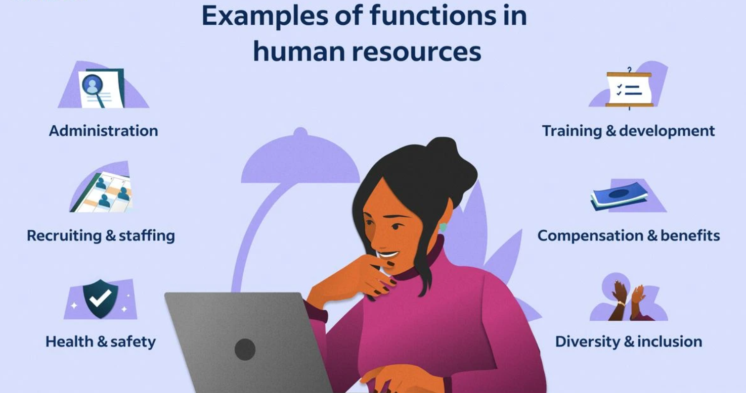
Figure 1.3.1 Functions of Human Resources (HR)

Information Technology (IT) and Technical Support Department:
Infrastructure Management: This includes managing servers, networks, hardware, and software systems to ensure seamless operation, security, and scalability.
Systems Administration: IT administrators monitor system performance, troubleshoot technical issues, install updates, and ensure data backups and recovery protocols are in place.
Cybersecurity: This team protects the organization from cyber threats by implementing firewalls, antivirus software, intrusion detection systems (IDS), and conducting regular security audits and assessments.
Software Development: IT professionals develop and maintain custom software applications, websites, and digital platforms to support internal operations and customer-facing solutions.
Technical Support: The IT helpdesk provides technical assistance, resolves user issues, and offers guidance on software usage, hardware configuration, and network connectivity.
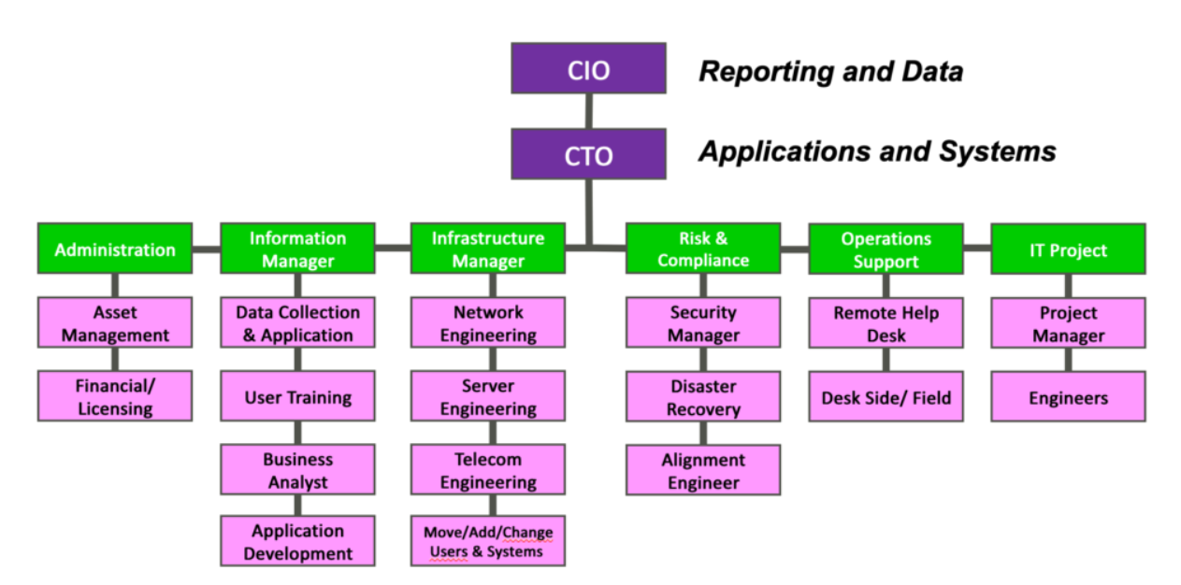
Figure 1.3.2 Information Technology (IT) Department Structure

Research and Development (R&D) Department:
Market Research and Analysis: R&D conducts market research to identify industry trends, customer preferences, and competitive landscapes to inform product development strategies.
Product Innovation: This team conceptualizes and prototypes new products, features, and services, leveraging emerging technologies and customer feedback to drive innovation.
Prototype Development: R&D builds and tests prototypes to validate concepts, assess feasibility, and gather user feedback before full-scale development and commercialization.
Intellectual Property Management: This involves securing patents, trademarks, and copyrights to protect the organization's innovations, inventions, and creative works from infringement.
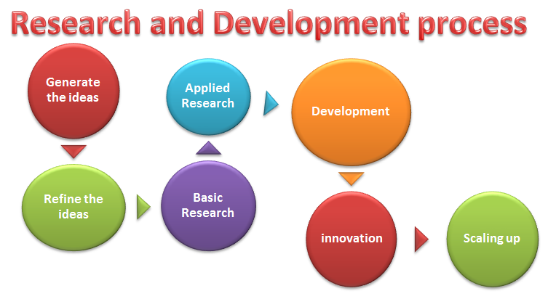
Figure1.3.3 Research & Development Process

Sales and Marketing Department:Market Segmentation and Targeting: Sales and marketing professionals identify and segment target markets based on demographics, behaviors, and preferences to tailor marketing messages and campaigns.
Lead Generation and Nurturing: This team generates leads through advertising, content marketing, and networking efforts, then nurtures those leads through email campaigns, follow-up calls, and personalized communication.
Brand Management: Sales and marketing professionals develop brand identity, messaging, and positioning strategies to differentiate EduPhoenix Solutions from competitors and build brand loyalty.
Digital Marketing: This involves leveraging digital channels such as websites, social media platforms, search engine optimization (SEO), and pay-per-click (PPC) advertising to reach and engage target audiences.
Sales Enablement: Sales enablement teams provide sales reps with the tools, resources, and training needed to effectively communicate product features, benefits, and value propositions to prospects and customers.

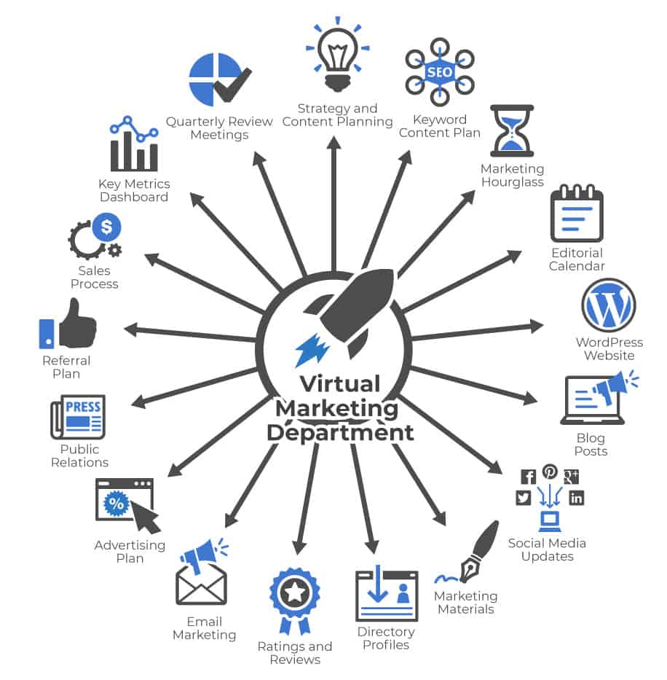

Figure 1.3.4(a) Virtual Marketing  Department | Figure 1.3.4(b) Marketing  Department

Customer Success Department:
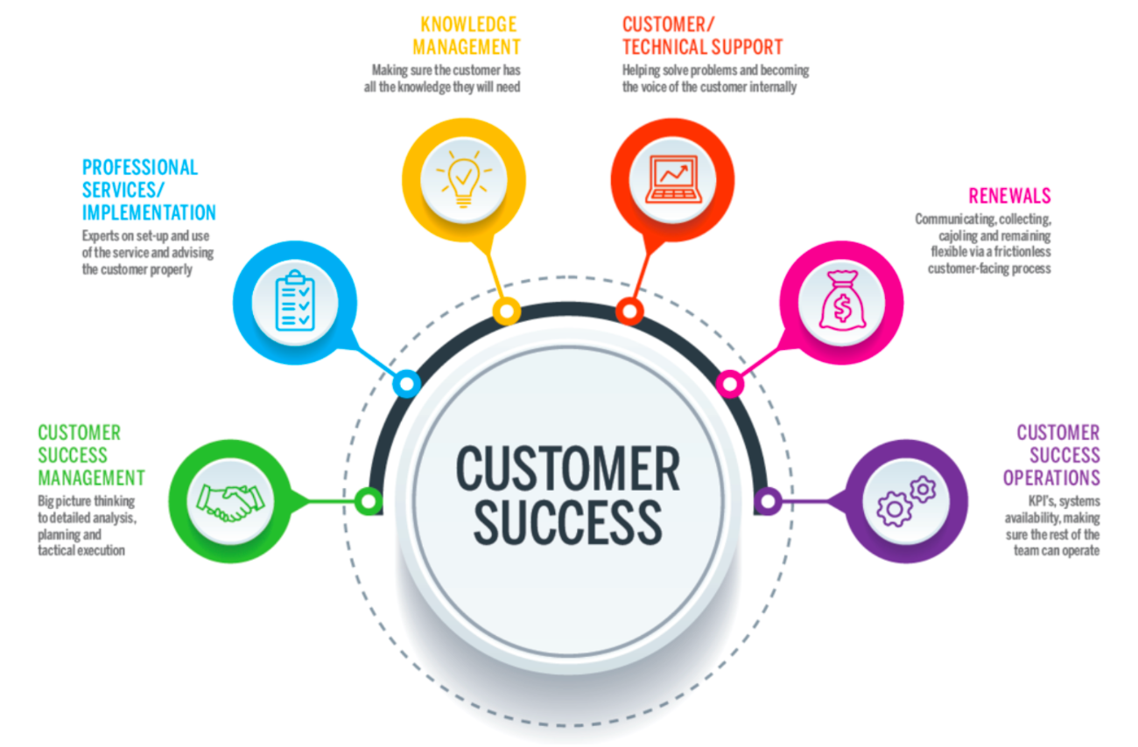
Customer Onboarding: This involves guiding new customers through the implementation process, providing training, support, and resources to ensure successful adoption and utilization of EduPhoenix Solutions.
Figure 1.3.5 Customer Success
Customer Relationship Management: Customer success managers build and nurture relationships with clients, acting as their advocate within the organization and ensuring their needs and expectations are met.
Account Management: This team is responsible for managing customer accounts, identifying upsell and cross-sell opportunities, and fostering long-term relationships to drive retention and expansion.
Customer Support: The customer support team provides responsive assistance, troubleshooting, and issue resolution to address customer inquiries, technical challenges, and service disruptions effectively.

Finance and Accounting Department:
Financial Planning and Analysis: This department is responsible for budgeting, forecasting, financial modeling, and providing insights to support strategic decision-making.
Accounts Payable and Receivable: Finance professionals manage payments to vendors, invoicing customers, and tracking receivables to ensure timely cash flow management.
Financial Reporting and Compliance: This team prepares financial statements, regulatory filings, and ensures compliance with accounting standards, tax laws, and industry regulations.
Treasury Management: Finance professionals oversee cash management, investment strategies, and risk mitigation to optimize liquidity and financial stability.

Figure 1.3.6 Finance & Accounting

Legal and Compliance Department:
Contract Management: Legal professionals draft, review, and negotiate contracts with clients, partners, and vendors to protect EduPhoenix Solutions' interests and mitigate legal risks.
Regulatory Compliance: This team ensures compliance with laws, regulations, and industry standards related to data privacy, security, intellectual property, and consumer protection.
Intellectual Property (IP) Management: Legal experts manage EduPhoenix Solutions' intellectual property portfolio, including patents, trademarks, copyrights, and trade secrets.
Risk Management: The legal and compliance department identifies, assesses, and manages legal and regulatory risks to minimize exposure and protect the organization from liabilities.
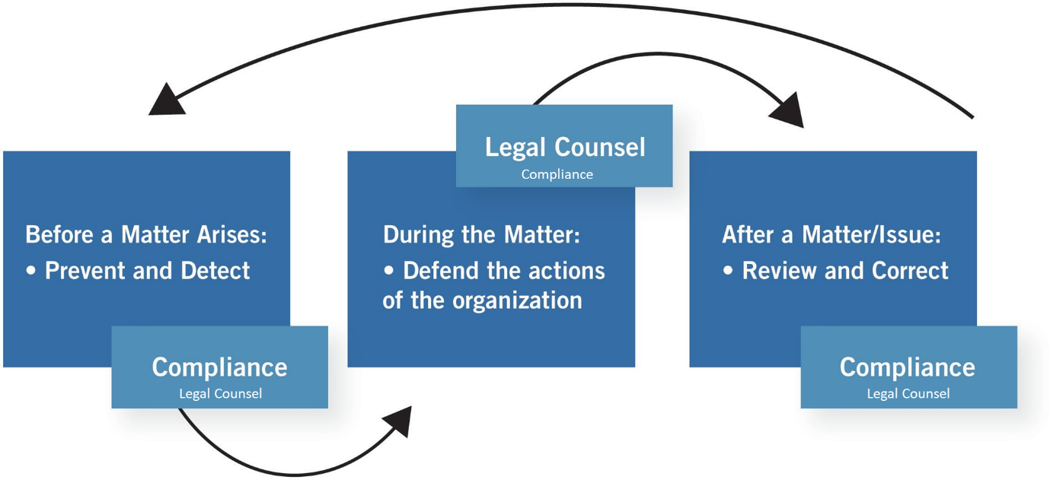
Figure 1.3.7 Legal & Compliance Procedure

Operations and Logistics Department:
Supply Chain Management: Operations professionals oversee procurement, inventory management, and logistics to ensure timely delivery of goods and services while optimizing costs and efficiency.
Facilities Management: This team maintains and manages office facilities, equipment, and infrastructure to create a safe, productive, and comfortable work environment.
Quality Assurance and Control: Operations experts develop and implement quality standards, processes, and metrics to ensure products and services meet or exceed customer expectations.

Figure 1.3.8(a) Operations  Management | Figure 1.3.8(b) Logistics

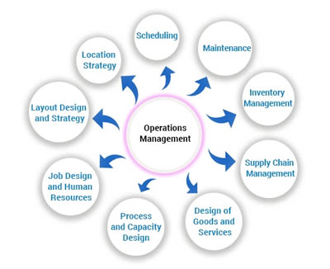
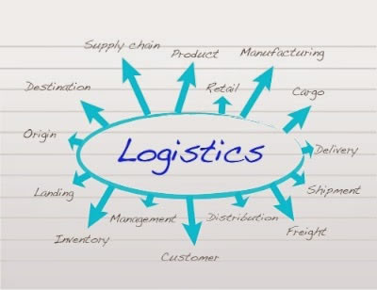
Project Management: Operations professionals coordinate cross-functional projects, allocate resources, and track progress to ensure timely completion and successful outcomes.

Customer Experience Department:
User Experience (UX) Design: This team focuses on designing intuitive, user-friendly interfaces and interactions for digital products and platforms to enhance customer satisfaction and engagement.
Customer Insights and Analytics: CX professionals analyze customer feedback, behavior data, and performance metrics to gain actionable insights and drive continuous improvement initiatives.
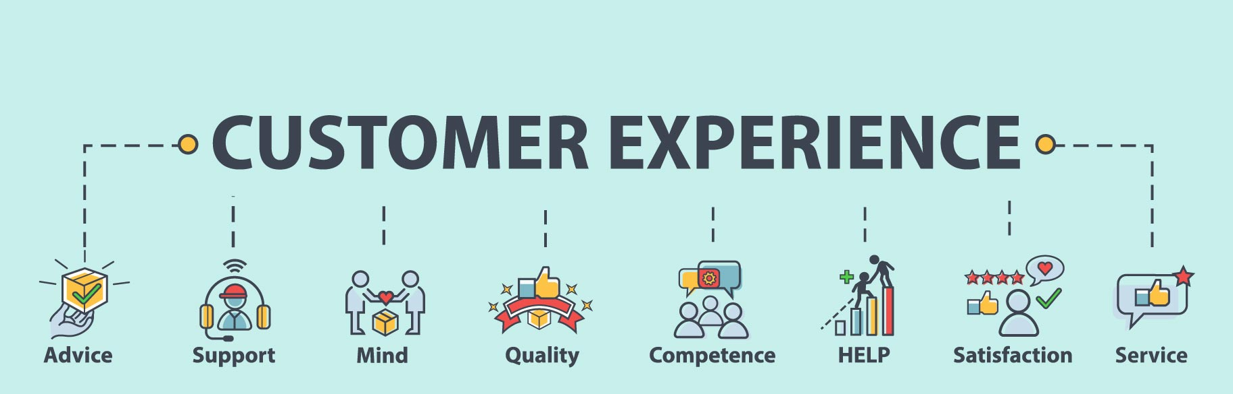
Customer Advocacy: This department represents the voice of the customer within the organization, advocating for their needs, preferences, and concerns to inform product development and decision-making.
Figure 1.3.9 Customer Experience
Customer Satisfaction and Retention: CX professionals develop strategies and programs to measure and improve customer satisfaction, loyalty, and retention rates through proactive engagement and personalized experiences.

Business Development and Partnerships Department:
Strategic Partnerships: Business development professionals identify and cultivate strategic alliances, joint ventures, and partnerships with other companies to expand market reach, access new resources, and drive growth.

Market Expansion: This team explores new markets, geographies, and customer segments to identify growth opportunities and develop market entry strategies to capitalize on emerging trends.
Channel Development: Business development experts establish and manage distribution channels, reseller networks, and affiliate programs to extend EduPhoenix Solutions' reach and increase sales volume.
Competitive Intelligence: This department monitors competitors' activities, market trends, and industry developments to identify threats and opportunities, inform strategic decision-making, and maintain a competitive edge. Figure 1.3.10 Business Development

Quality Assurance and Testing Department:
Quality Assurance (QA) Testing is a critical function that ensures products and services meet specified quality standards before they are released to customers. This involves systematically testing various aspects of software, hardware, or other deliverables to identify defects or areas for improvement.
QA testers develop comprehensive test plans, scenarios, and scripts based on project requirements and specifications. These documents outline the testing approach, test cases, and expected outcomes for each test scenario.
Different types of testing are performed throughout the development lifecycle, including functional testing, which verifies that the system meets specified functional requirements, and regression testing, which ensures that new changes do not adversely impact existing functionality.

Figure 1.3.11(a) Quality Assurance | Figure 1.3.11(b) Testing

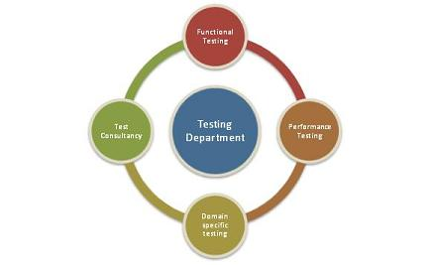
User acceptance testing (UAT) is conducted to validate the product against user expectations and requirements. This involves engaging end-users to evaluate the product's usability, accessibility, and overall user experience.
QA testers use a variety of testing techniques and tools to identify defects and bugs in the system. This may include manual testing, automated testing, performance testing, security testing, and usability testing, among others.
Throughout the testing process, QA testers document their findings, including any defects or issues discovered during testing. They work closely with development teams to prioritize and address these issues, ensuring that high-priority defects are resolved promptly.
Continuous improvement is a key aspect of QA testing, with testers regularly reviewing and refining testing processes and methodologies to enhance efficiency and effectiveness. This may involve implementing new tools, adopting best practices, and incorporating feedback from stakeholders to drive quality improvements.
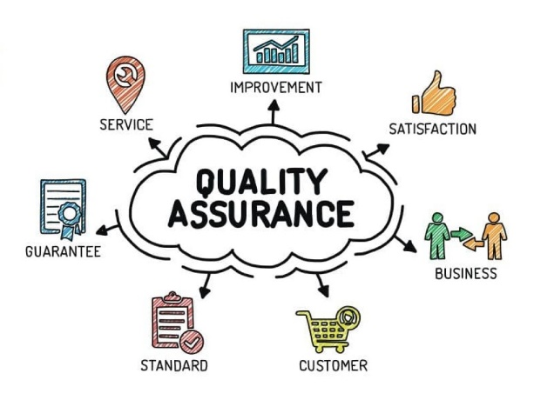
Grievance and Conflict Resolution Department:
The Grievance and Conflict Resolution department is responsible for managing disputes, grievances, and conflicts within the organization. This department serves as a neutral mediator, helping parties resolve issues in a fair and equitable manner.
One of the primary functions is to provide employees and stakeholders with a platform to express their concerns and grievances. This could involve setting up confidential reporting mechanisms, such as hotlines or online portals, where individuals can raise issues anonymously.
The department investigates complaints and conflicts thoroughly, gathering relevant information and evidence to understand the root causes of the problem. Depending on the nature of the issue, this may involve conducting interviews, reviewing documentation, or engaging in alternative dispute resolution methods like mediation or arbitration.
Once the investigation is complete, the department works towards finding a resolution that addresses the concerns of all parties involved. This could involve implementing corrective actions, revising policies or procedures, or providing training and support to prevent similar issues from arising in the future.
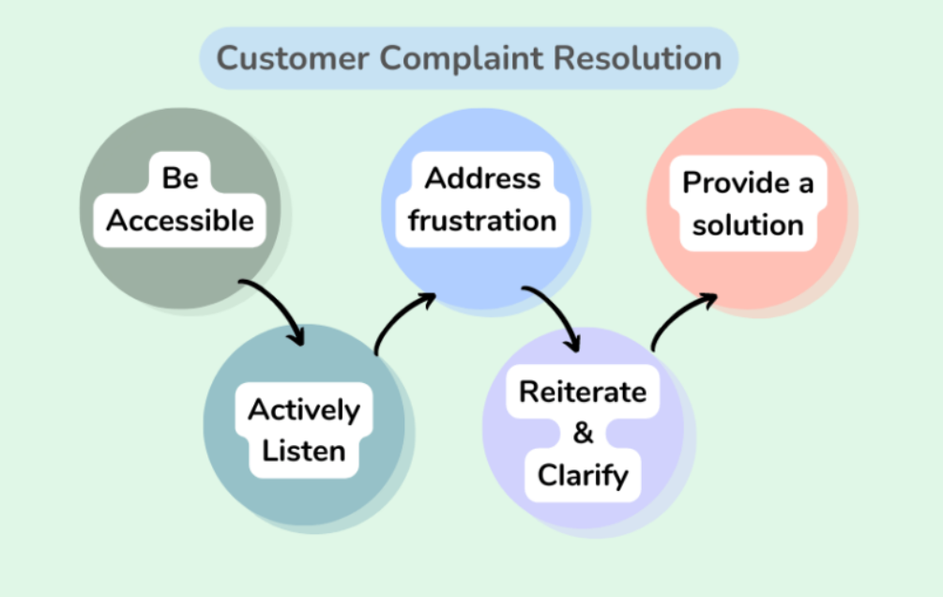
Figure 1.3.12 Customer Complaint Resolution
Additionally, the Grievance and Conflict Resolution department may play a role in promoting a positive organizational culture by fostering open communication, trust, and collaboration among employees. This includes promoting conflict resolution skills and providing resources for managing interpersonal conflicts effectively.

These departments play integral roles in ensuring the success and growth of EduPhoenix Solutions by effectively managing resources, delivering high-quality products and services, and delivers comprehensive educational solutions that empower learners, educators, and institutions to succeed in a rapidly evolving digital landscape.

  - Company Products/Applications
EduPhoenix Solutions prides itself on offering a diverse array of cutting-edge educational technology products and applications designed to cater to the evolving needs of educators and learners alike. Our commitment to innovation and excellence drives us to develop solutions that enhance teaching effectiveness, promote student engagement, and ultimately elevate the learning experience. Here's a detailed overview of our key products and applications:
- Learning Management System (LMS):
Our Learning Management System (LMS) serves as the cornerstone of our educational technology suite. This robust platform provides educators with the tools they need to create, deliver, and manage online courses and educational content seamlessly. With intuitive course creation features, comprehensive content management capabilities, and robust assessment tools, our LMS empowers educators to design dynamic and interactive learning experiences. Moreover, real-time analytics and reporting functionalities enable educators to monitor student progress and performance effectively.

- Virtual Classroom:
In today's digital age, our Virtual Classroom platform offers educators a versatile and immersive online learning environment. Equipped with video conferencing, screen sharing, interactive whiteboards, and chat functionality, this platform facilitates real-time collaboration and interaction between educators and students. Whether conducting live classes, webinars, or virtual workshops, educators can engage learners effectively and foster meaningful learning experiences. Seamless integration with our LMS ensures streamlined course delivery and administration.

- Interactive Content Authoring Tools:
Our suite of interactive content authoring tools empowers educators to create engaging and multimedia-rich learning materials with ease. Featuring user-friendly interfaces, customizable templates, and multimedia integration capabilities, these authoring tools enable educators to develop interactive presentations, quizzes, simulations, and games effortlessly. With built-in assessment and tracking features, educators can assess student comprehension and progress in real time, ensuring that learning objectives are met effectively.

- Professional Development Programs:
Recognizing the importance of continuous professional development, we offer a wide range of training courses and programs designed to enhance educators' skills and knowledge in educational technology and pedagogy. From digital literacy and blended learning to instructional design and technology integration, our professional development programs cover a diverse array of topics. Whether educators are looking to expand their expertise in specific areas or earn certifications in educational technology, our programs provide valuable opportunities for growth and advancement.
- Consultancy Services:
Our consultancy services cater to educational institutions seeking expert guidance and support in leveraging technology for teaching and learning. Our team of seasoned consultants collaborates closely with clients to assess their unique needs, develop tailored technology solutions, and provide ongoing training and support. From strategic planning and needs analysis to implementation and evaluation, our consultancy services empower institutions to maximize the impact of educational technology and achieve their educational goals effectively.

- IoT Projects:
Internet of Things (IoT) projects involve the integration of physical devices, sensors, and software applications to enable connectivity and data exchange. These projects often focus on leveraging IoT technologies to create smart systems, automate processes, and gather insights from real-world data. Eduphoenix Solutions offers a range of IoT projects aimed at providing hands-on learning experiences to students and professionals.
These projects typically cover areas such as:
Sensor Integration: Students learn to integrate various sensors such as temperature sensors, humidity sensors, motion sensors, and environmental sensors into IoT devices and systems.
Data Acquisition and Processing: Projects involve collecting data from sensors and processing it using microcontrollers or single-board computers like Arduino, Raspberry Pi, or ESP8266/ESP32.
Connectivity and Communication: Students explore different communication protocols such as Wi-Fi, Bluetooth, Zigbee, and LoRa to enable connectivity between IoT devices and networks.
IoT Applications: Projects may focus on developing IoT applications for smart homes, smart cities, industrial automation, healthcare monitoring, environmental monitoring, agriculture, and more.
Cloud Integration: Integration with cloud platforms such as AWS IoT, Google Cloud IoT, or Microsoft Azure IoT enables students to store, analyze, and visualize IoT data, as well as implement cloud-based services like remote monitoring and control.
Security and Privacy: Emphasis is placed on implementing security measures such as encryption, authentication, and access control to protect IoT systems from cyber threats and ensure data privacy.

- AI-ML Projects:
Artificial Intelligence (AI) and Machine Learning (ML) projects involve the development and application of algorithms and models to analyze data, make predictions, and automate tasks without explicit programming instructions. These projects harness the power of AI and ML techniques to solve complex problems, optimize processes, and extract insights from data. Eduphoenix Solutions offers a variety of AI-ML projects aimed at fostering understanding and proficiency in these transformative technologies.
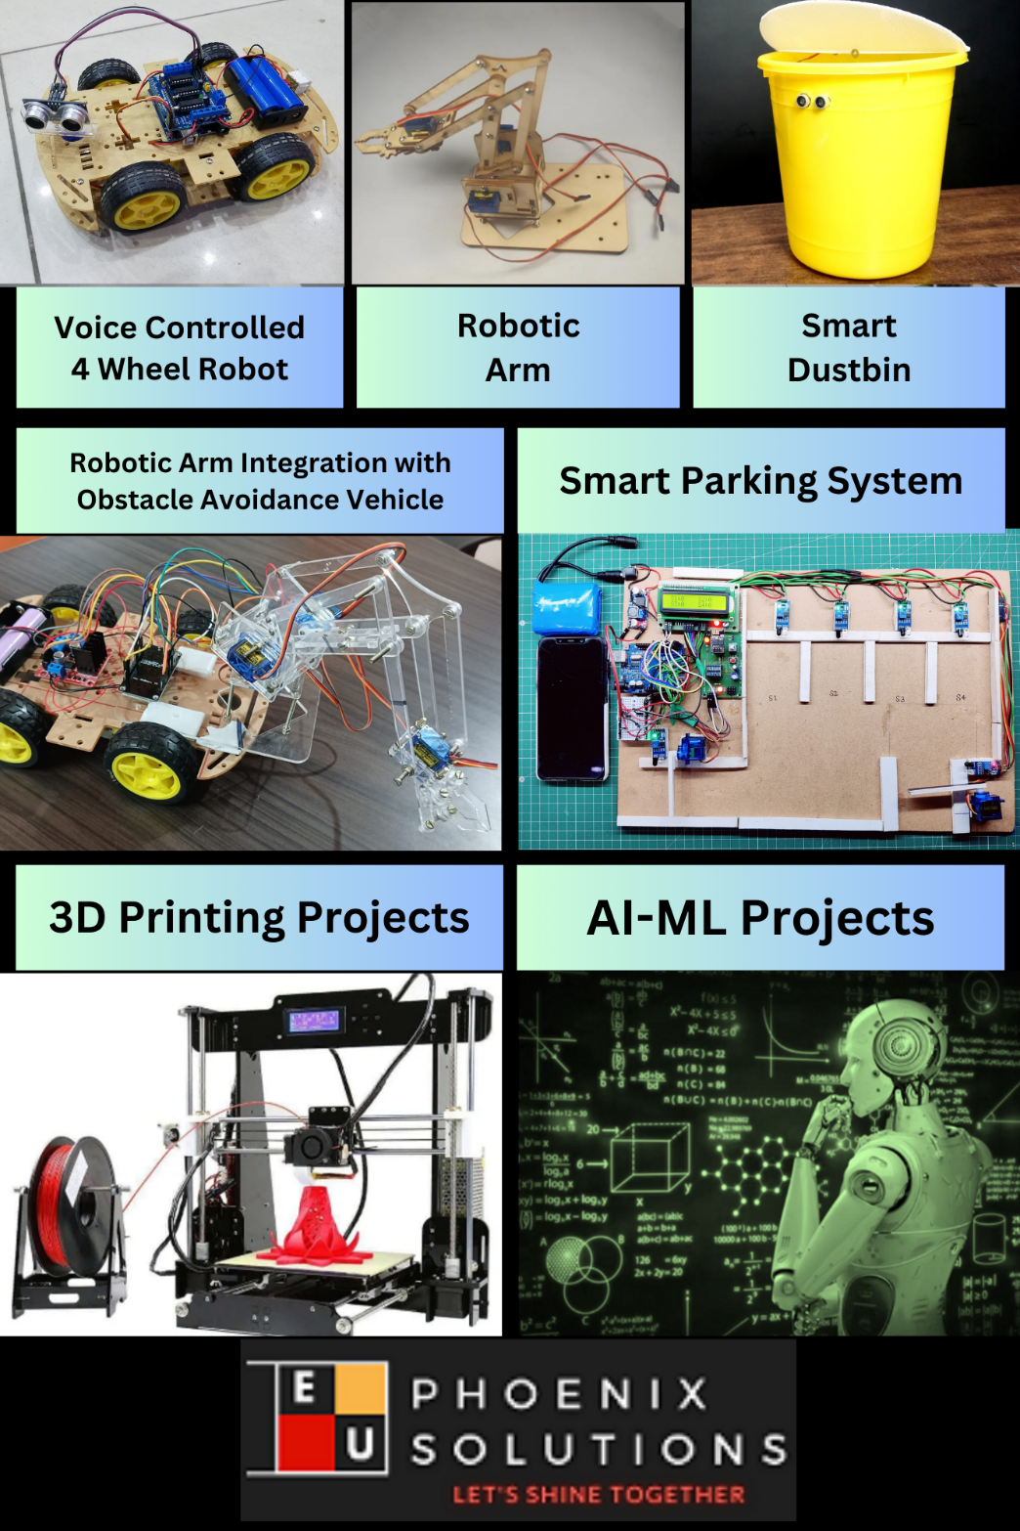

Figure 1.4.1 Company Products

Key components of AI-ML projects include:
Data Collection and Preparation: Projects begin with data collection from various sources such as sensors, databases, or web APIs. Data preprocessing techniques are then applied to clean, transform, and prepare the data for analysis.
Algorithm Selection and Model Development: Students explore different AI and ML algorithms such as regression, classification, clustering, neural networks, and deep learning to build predictive models and solve specific problems.
Model Training and Evaluation: The models are trained using abelled data, and their performance is evaluated using metrics such as accuracy, precision, recall, and F1-score. Hyperparameter tuning and cross-validation techniques are applied to optimize model performance.
Deployment and Integration: Once trained and evaluated, the models are deployed into production environments and integrated with existing systems or applications to deliver real-world value. This may involve deploying models on edge devices, cloud platforms, or IoT devices.

Overall, IoT and AI-ML projects offered by EduPhoenix Solutions provide participants with practical experience, critical thinking skills, and technical expertise in emerging technologies, preparing them for careers in the rapidly evolving fields of IoT and AI-ML.

CHAPTER 2
DOMAIN: DATA SCIENCE

2.1 Introduction
In the digital era, data has become the cornerstone of decision-making processes across industries. From predicting customer preferences to optimizing business operations, organizations rely on data-driven insights to gain a competitive edge in the market. Data Science, as a multidisciplinary field, lies at the intersection of statistics, computer science, and domain expertise, offering a systematic approach to extract actionable insights from vast and complex datasets.
Data Science encompasses a wide range of techniques and methodologies aimed at uncovering patterns, trends, and relationships within data to drive informed decision-making. By leveraging advanced analytics, machine learning algorithms, and computational tools, Data Scientists transform raw data into valuable insights, enabling organizations to solve complex problems, identify opportunities, and mitigate risks effectively.
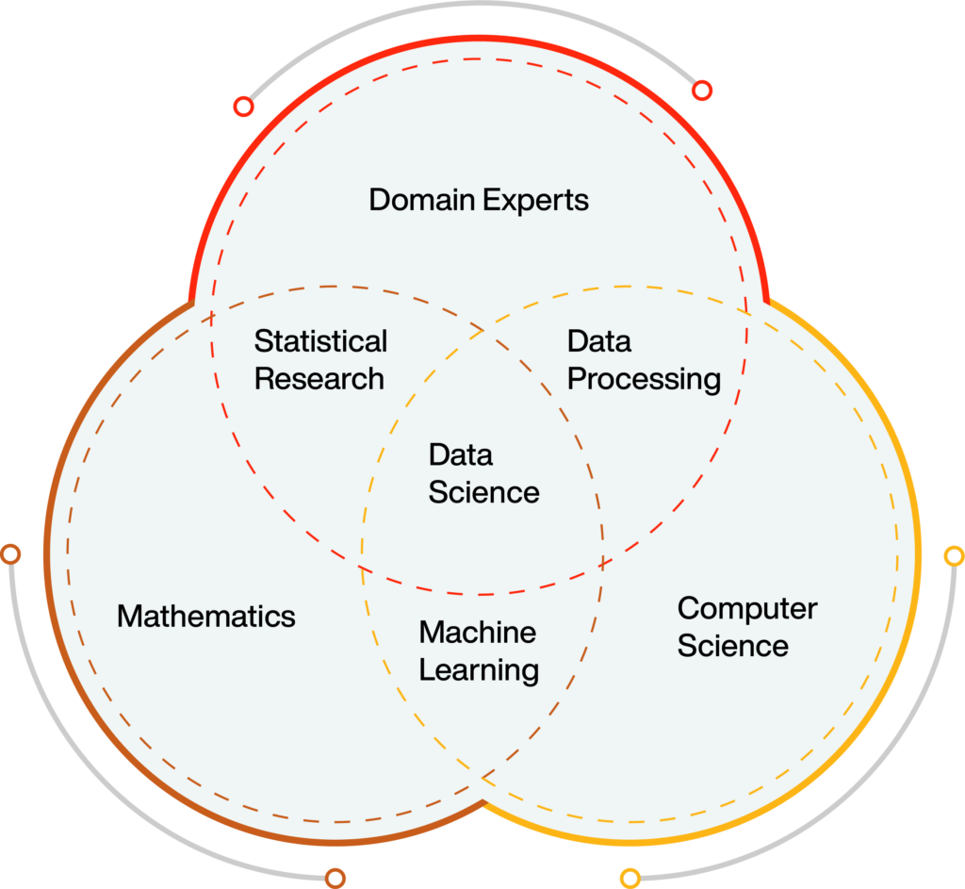
Figure 2.1 Data Science
As businesses continue to generate exponential amounts of data, the demand for skilled Data Scientists has skyrocketed. These professionals possess a unique blend of technical skills, including proficiency in programming languages like Python and R, expertise in statistical analysis and machine learning algorithms, and the ability to interpret and communicate findings to diverse stakeholders.
Through this internship at EduPhoenix Solutions, we delve into the dynamic field of Data Science, exploring its methodologies, tools, applications, and future trends. By gaining hands-on experience in data manipulation, visualization, predictive modeling, and data-driven decision-making, interns will acquire the essential skills and knowledge required to excel in the rapidly evolving landscape of Data Science.
Throughout this internship program, interns will have the opportunity to work on real-world projects, collaborate with industry experts, and contribute to the development of innovative solutions that harness the power of data to drive business success. By immersing themselves in the practical application of Data Science techniques and methodologies, interns will emerge as adept practitioners capable of making meaningful contributions to organizations' data-driven initiatives.
In summary, this internship at EduPhoenix Solutions serves as a gateway for aspiring Data Scientists to embark on a rewarding journey in the field of Data Science, equipping them with the skills, knowledge, and experience needed to thrive in an increasingly data-centric world. Through hands-on learning, mentorship, and exposure to cutting-edge technologies, interns will be empowered to harness the transformative potential of data and drive impactful outcomes for businesses and society at large.

2.2 Overview
In today's digital landscape, the proliferation of data has transformed the way organizations operate, offering unprecedented opportunities for insights-driven decision-making. Data Science, as a multidisciplinary field, encompasses a wide range of techniques, methodologies, and tools aimed at extracting actionable insights from large and complex datasets. At EduPhoenix Solutions, the exploration of Data Science begins with a comprehensive overview that delves into the fundamental concepts, methodologies, and applications within this dynamic domain.
- Foundations of Data Science:
At the heart of Data Science lies a solid foundation in statistics, mathematics, and computer science. Interns at EduPhoenix Solutions embark on a journey to understand the theoretical underpinnings of Data Science, exploring concepts such as probability theory, linear algebra, and calculus. By mastering these foundational principles, interns gain the analytical prowess needed to manipulate, analyze, and interpret data effectively.
- Data Acquisition and Preprocessing:
Data Science begins with the collection and preprocessing of raw data from various sources. EduPhoenix Solutions provides interns with hands-on experience in data acquisition techniques, including web scraping, APIs, and databases. Interns learn to clean, preprocess, and transform data to ensure its quality, consistency, and suitability for analysis.
- Exploratory Data Analysis (EDA):
Exploratory Data Analysis (EDA) forms a crucial step in the Data Science workflow, enabling interns to gain insights into the underlying patterns, trends, and relationships within the data. Through visualizations, summary statistics, and hypothesis testing, interns uncover key insights that inform subsequent analysis and decision-making processes.
- Machine Learning and Predictive Modeling:
Machine Learning lies at the forefront of Data Science, empowering organizations to build predictive models that uncover hidden patterns and relationships within data. EduPhoenix Solutions immerses interns in the world of machine learning, covering algorithms such as linear regression, decision trees, and neural networks. Interns learn to train, evaluate, and deploy machine learning models to solve real-world problems across various domains.
- Big Data and Distributed Computing:
As datasets continue to grow in size and complexity, the ability to process and analyze big data becomes increasingly critical. EduPhoenix Solutions equips interns with the tools and techniques needed to work with big data frameworks such as Apache Hadoop and Apache Spark. Interns learn to leverage distributed computing paradigms to handle massive datasets efficiently and extract actionable insights at scale.
- Deep Learning and Artificial Intelligence:
Advancements in Deep Learning and Artificial Intelligence have revolutionized the field of Data Science, enabling the development of complex models capable of learning from vast amounts of data. EduPhoenix Solutions exposes interns to deep learning frameworks such as TensorFlow and PyTorch, allowing them to explore advanced neural network architectures and applications in image recognition, natural language processing, and more.
- Applications of Data Science:
Data Science finds applications across a wide range of industries and domains, from finance and healthcare to marketing and cybersecurity. EduPhoenix Solutions provides interns with exposure to real-world projects and use cases, allowing them to apply their skills and expertise to solve complex problems and drive business outcomes.
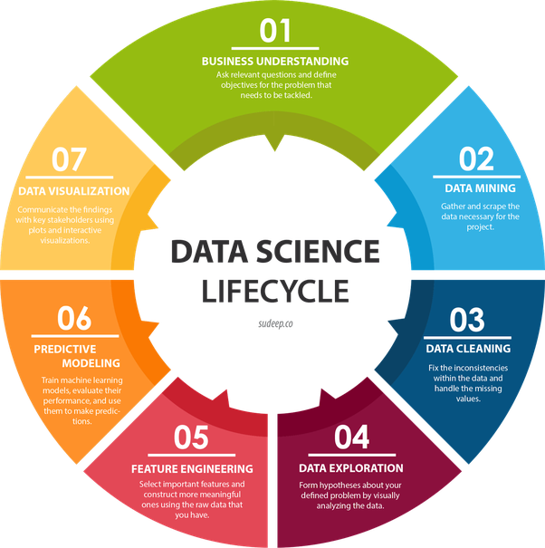
Figure 2.2 Data Science Lifecycle
In summary, the overview of Data Science at EduPhoenix Solutions provides interns with a comprehensive understanding of the principles, methodologies, and applications within this dynamic field. By mastering the foundational concepts, exploring cutting-edge technologies, and applying their skills to real-world projects, interns emerge prepared to tackle the challenges and opportunities in the ever-evolving landscape of Data Science.
2.3 Data Acquisition
Data acquisition is the process of collecting raw data from various sources to be used for analysis and modeling in data science projects. At EduPhoenix Solutions, interns are trained in comprehensive data acquisition techniques to gather relevant and high-quality data for their projects.
Key Components of Data Acquisition:
- Identifying Data Sources: Interns begin by identifying the sources from which data will be collected. These sources may include databases, APIs, web scraping, sensor networks, social media platforms, IoT devices, and third-party data providers. Understanding the nature of each data source is essential for effective acquisition.

- Accessing Structured Databases: For structured data stored in databases, interns use SQL queries to extract relevant datasets. They interact with database management systems (DBMS) such as MySQL, PostgreSQL, or SQLite to retrieve specific tables or records that are needed for analysis.

- Web Scraping: When data is not readily available in structured formats, interns employ web scraping techniques to extract information from websites. They use tools like BeautifulSoup in Python to parse HTML and extract data elements such as text, tables, or images from web pages.

- API Integration: Many platforms offer APIs (Application Programming Interfaces) that allow developers to programmatically access their data. Interns leverage APIs to retrieve data from services like Twitter, Facebook, Google Maps, and financial markets. They use authentication tokens and API endpoints to access specific data endpoints.

- Sensor Data Collection: In projects involving IoT (Internet of Things) or sensor networks, interns collect data from physical sensors embedded in devices or equipment. This may include temperature sensors, pressure sensors, motion detectors, or GPS trackers. They use protocols like MQTT or HTTP to communicate with sensor nodes and collect streaming data.

- Social Media Data Mining: For projects involving social media analysis or sentiment analysis, interns gather data from platforms like Twitter, Facebook, Reddit, or LinkedIn. They utilize APIs provided by these platforms to access user-generated content, hashtags, likes, shares, and comments for analysis.

- Data Cleaning and Preprocessing: Once data is acquired, interns perform data cleaning and preprocessing to ensure its quality and usability for analysis. This involves tasks such as removing duplicates, handling missing values, standardizing formats, and transforming data into a suitable structure for analysis.
- Data Privacy and Compliance: Interns adhere to data privacy regulations and ethical guidelines when acquiring data, especially when dealing with sensitive or personally identifiable information (PII). They ensure compliance with regulations like GDPR, HIPAA, or CCPA and implement measures to protect data privacy and security.
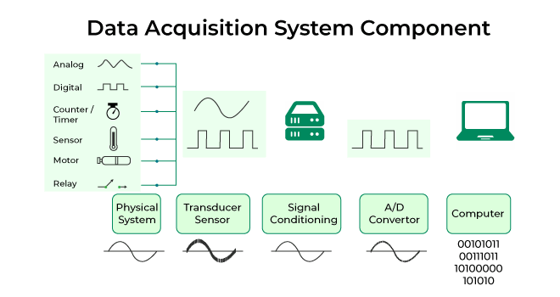
Figure 2.3 Data Acquisition System
By mastering these data acquisition techniques, interns at EduPhoenix Solutions can effectively collect diverse datasets from various sources, enabling them to perform insightful analyses and develop impactful data-driven solutions for business challenges.

2.4 Data Preparation and Preprocessing
Data preparation and preprocessing are crucial steps in the data science workflow that involve cleaning, transforming, and organizing raw data into a format suitable for analysis and modeling. At EduPhoenix Solutions, interns are trained in comprehensive data preparation and preprocessing techniques to ensure the quality and integrity of the data used in their projects.
Key Components of Data Preparation and Preprocessing:
- Data Cleaning: Interns start by identifying and addressing issues such as missing values, duplicates, inconsistencies, and errors in the dataset. They employ techniques like imputation, deletion, or interpolation to handle missing data and remove redundant or irrelevant observations.

- Data Transformation: After cleaning the data, interns perform transformations to standardize or normalize the features. This may involve scaling numerical variables to a common range, encoding categorical variables into numerical representations, or applying logarithmic or power transformations to skewed data distributions.

- Feature Engineering: Feature engineering involves creating new features or deriving meaningful insights from existing ones to improve model performance. Interns may generate new features by combining existing variables, extracting relevant information from text or timestamps, or encoding temporal or spatial relationships within the data.

- Dimensionality Reduction: In cases where the dataset contains a large number of features, interns employ dimensionality reduction techniques to reduce the complexity of the data while preserving its essential information. This may involve methods such as principal component analysis (PCA) or feature selection algorithms to identify the most relevant features for modeling.

- Outlier Detection and Treatment: Interns identify outliers or anomalies in the dataset that may adversely affect model performance. They use statistical methods or machine learning algorithms to detect outliers and decide whether to remove them, transform them, or treat them separately in the analysis.

- Data Integration: When working with multiple datasets or sources, interns integrate and merge the data to create a unified dataset for analysis. They ensure compatibility between datasets by standardizing variables, resolving naming inconsistencies, and aligning data structures.

- Temporal and Spatial Aggregation: For time-series or spatial data, interns aggregate the data at different temporal or spatial granularities to extract meaningful patterns or trends. This may involve aggregating data into hourly, daily, or monthly intervals or summarizing spatial data into regions or clusters.
- Data Sampling: In cases where the dataset is too large or imbalanced, interns may employ data sampling techniques to create representative subsets for analysis. This may include random sampling, stratified sampling, or oversampling/undersampling methods to balance class distributions.
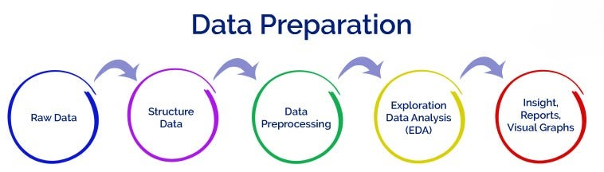
Figure 2.4(a) Data Preparation
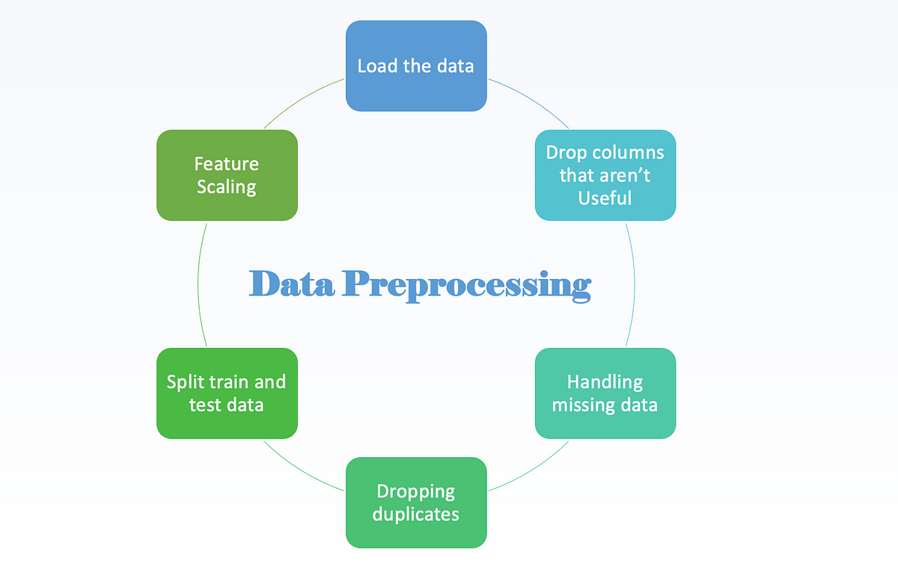
Figure 2.4(b) Data Preprocessing
By mastering these data preparation and preprocessing techniques, interns at EduPhoenix Solutions can ensure that the data used in their projects is clean, consistent, and well-structured, enabling them to build accurate and reliable predictive models and extract valuable insights for business decision-making.

2.5 Exploratory Data Analysis (EDA)
Exploratory Data Analysis (EDA) is a crucial phase in the data science workflow, where analysts explore and visualize datasets to gain insights and identify patterns. At EduPhoenix Solutions, interns are trained in various techniques and methodologies involved in EDA to uncover hidden trends and relationships in data.
Key Components of EDA:
- Descriptive Statistics: Interns learn to compute and interpret descriptive statistics such as mean, median, mode, standard deviation, and range to summarize the central tendency and variability of data.

- Data Visualization: Visualization plays a vital role in EDA, enabling interns to create informative plots and charts to visualize the distribution, trends, and relationships within the data. Techniques such as histograms, box plots, scatter plots, and heatmaps are utilized to explore different aspects of the dataset.

- Data Cleaning and Imputation: Before conducting EDA, interns perform data cleaning to address missing values, outliers, and inconsistencies in the dataset. Imputation techniques such as mean imputation, median imputation, and interpolation are applied to handle missing data.

- Correlation Analysis: Interns analyze the correlation between variables to identify potential relationships and dependencies. Correlation matrices and scatter plots are used to visualize the strength and direction of relationships between numerical variables.

- Feature Engineering: Feature engineering is an essential aspect of EDA, where interns create new features or transform existing ones to improve the performance of machine learning models. Techniques such as binning, one-hot encoding, and feature scaling are applied to prepare the data for modeling.

- Dimensionality Reduction: In cases where the dataset contains a large number of features, interns use dimensionality reduction techniques such as principal component analysis (PCA) and t-distributed stochastic neighbor embedding (t-SNE) to reduce the dimensionality of the data while preserving important information.

- Cluster Analysis: Interns explore cluster analysis techniques such as k-means clustering and hierarchical clustering to identify natural groupings or clusters within the data. Cluster visualization techniques such as dendrograms and silhouette plots are used to evaluate the quality of clustering results.

- Outlier Detection: Outliers can significantly impact the results of data analysis. Interns employ outlier detection techniques such as z-score, modified z-score, and isolation forests to identify and remove outliers from the dataset.

- Data Transformation: Transforming the data into a more suitable form for analysis is an important step in EDA. Techniques such as logarithmic transformation, square root transformation, and normalization are applied to ensure that the data meets the assumptions of statistical tests and models.
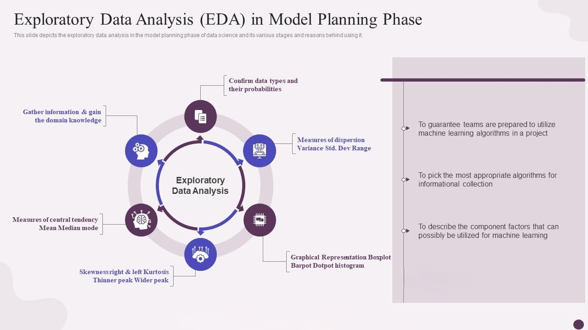
Figure 2.5 Exploratory Data Analysis (EDA)
In summary, Exploratory Data Analysis (EDA) is a critical phase in the data science process, allowing interns at EduPhoenix Solutions to gain a deeper understanding of the dataset and uncover valuable insights that drive informed decision-making and further analysis. Through practical training in EDA techniques, interns develop the skills and expertise needed to extract meaningful information from data and deliver actionable insights to stakeholders.

2.6 Model Selection
Model selection is a critical step in the data science process that involves choosing the most appropriate machine learning algorithm or statistical model for a given dataset and problem domain. At EduPhoenix Solutions, interns are trained in various model selection techniques to ensure that the chosen model effectively captures the underlying patterns and relationships in the data.
Key Considerations in Model Selection:
- Problem Understanding: Before selecting a model, interns thoroughly understand the problem domain, objectives, and constraints. This involves defining the prediction task, identifying the target variable, and determining the type of problem (e.g., classification, regression, clustering).

- Exploratory Data Analysis (EDA): Interns conduct EDA to gain insights into the characteristics and distributions of the dataset. This helps in identifying potential relationships between variables, detecting outliers, and understanding the underlying data patterns, which guide the selection of appropriate models.

- Feature Selection and Engineering: Feature selection involves identifying the most relevant features or variables that contribute to the predictive performance of the model. Interns use techniques such as correlation analysis, feature importance ranking, and dimensionality reduction to select or create informative features for modeling.

- Algorithm Selection: Based on the problem type, dataset characteristics, and performance requirements, interns evaluate different machine learning algorithms and statistical models. Common algorithms include linear regression, logistic regression, decision trees, random forests, support vector machines, neural networks, and clustering algorithms such as k-means and hierarchical clustering.

- Model Evaluation Metrics: Interns select appropriate evaluation metrics to assess the performance of candidate models. For classification tasks, metrics such as accuracy, precision, recall, F1 score, and ROC curve are used, while regression tasks may use metrics like mean squared error (MSE), mean absolute error (MAE), or R-squared.

- Cross-Validation: To assess the generalization performance of models and mitigate overfitting, interns employ techniques like k-fold cross-validation. This involves splitting the dataset into k subsets, training the model on k-1 subsets, and evaluating it on the remaining subset iteratively, ensuring that each data point is used for both training and validation.

- Hyperparameter Tuning: Interns optimize model performance by tuning hyperparameters, which are settings that control the learning process of the algorithm. Techniques such as grid search, random search, and Bayesian optimization are used to find the optimal combination of hyperparameters that maximize model performance.

- Validation and Testing: Once the final model is selected, interns validate its performance on a held-out validation dataset or through cross-validation. Additionally, the model's performance is evaluated on an unseen test dataset to assess its ability to generalize to new data.

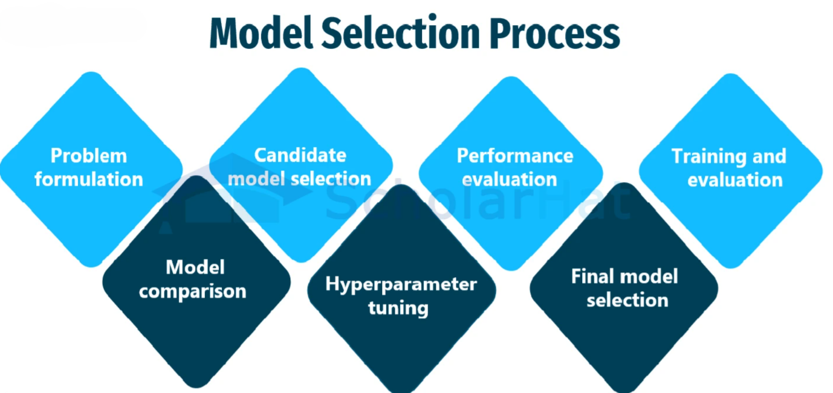
Figure 2.6 Model Selection Process
By carefully considering these factors and methodologies, interns at EduPhoenix Solutions are equipped to select and deploy robust and reliable models that effectively address real-world challenges and deliver actionable insights for stakeholders.

CHAPTER 3
INTERNSHIP TASK/DAILY-LOGS

CHAPTER 4
PROJECT

CHAPTER 5
CAREER OPPORTUNITIES

Data science offers a wide range of exciting career opportunities for individuals with skills in data analysis, machine learning, and statistics. At EduPhoenix Solutions, interns are exposed to various career paths within the field of data science and are equipped with the necessary skills and knowledge to pursue these opportunities.
1. Data Analyst: Data analysts are responsible for collecting, processing, and analyzing large datasets to extract actionable insights. They work closely with stakeholders to understand business requirements and deliver data-driven solutions to solve problems and drive decision-making.
2. Data Scientist: Data scientists leverage advanced statistical and machine learning techniques to build predictive models and uncover hidden patterns in data. They develop algorithms and models to solve complex business problems, such as customer segmentation, demand forecasting, and recommendation systems.
3. Machine Learning Engineer: Machine learning engineers focus on developing and deploying machine learning algorithms and models into production systems. They work on tasks such as model training, optimization, and deployment, and collaborate with data scientists and software engineers to integrate machine learning solutions into applications and platforms.
4. Business Intelligence Analyst: Business intelligence analysts use data visualization tools and techniques to create informative dashboards, reports, and visualizations that help organizations understand and interpret their data. They communicate insights to stakeholders and provide actionable recommendations for business strategy and decision-making.
5. Data Engineer: Data engineers are responsible for designing, building, and maintaining data pipelines and infrastructure that support the storage, processing, and analysis of large-scale datasets. They work with technologies such as databases, data warehouses, and cloud platforms to ensure data accessibility, reliability, and scalability.
6. Big Data Analyst: Big data analysts specialize in working with large and complex datasets, often sourced from diverse sources such as social media, IoT devices, and sensors. They use distributed computing frameworks like Hadoop and Spark to process and analyze massive volumes of data and extract valuable insights.
7. Predictive Modeler: Predictive modelers develop and implement statistical models and algorithms to forecast future trends, behaviors, or events based on historical data. They apply techniques such as regression analysis, time series forecasting, and predictive modeling to solve business problems and improve decision-making.
8. Data Science Consultant: Data science consultants provide advisory services and strategic guidance to organizations on how to leverage data science and analytics to achieve their business objectives. They assess business needs, design customized solutions, and help clients implement data-driven strategies to drive growth and innovation.
9. Research Scientist: Research scientists work in academia, research institutions, or industry labs to advance the state-of-the-art in data science and machine learning. They conduct research, publish papers, and develop novel algorithms and techniques to address challenging problems in areas such as natural language processing, computer vision, and reinforcement learning.
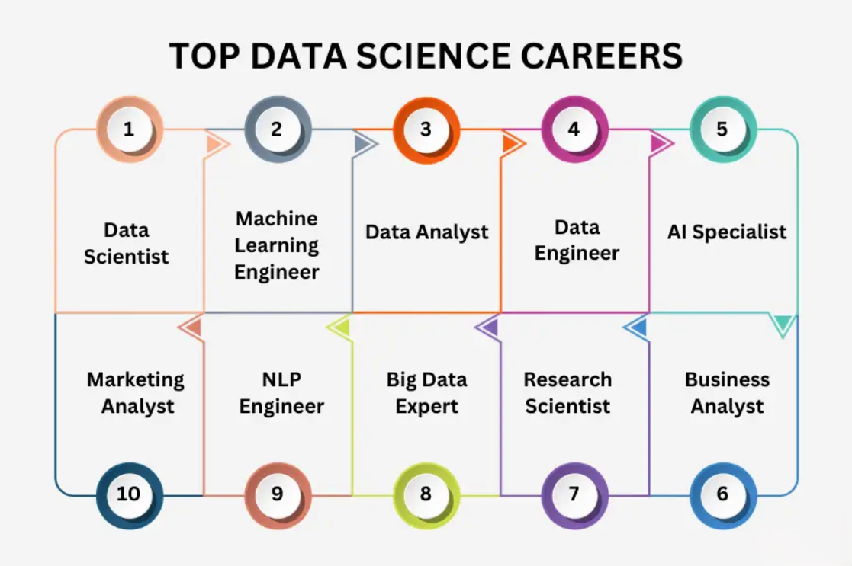
Figure 5 Top Data Science Careers
10. Data Science Educator: Data science educators teach and train individuals in the principles and practices of data science through academic programs, workshops, and online courses. They design curriculum, develop course materials, and mentor students to help them acquire the skills and knowledge needed to succeed in the field of data science.
11. Healthcare Data Analyst: Healthcare data analysts work in the healthcare industry, analyzing patient data, medical records, and clinical trials to improve patient outcomes, optimize healthcare delivery, and support medical research.
12. Fraud Analyst: Fraud analysts use data analytics techniques to detect and prevent fraudulent activities, such as identity theft, financial fraud, and cybercrime. They analyze patterns and anomalies in transaction data to identify suspicious behavior and mitigate risks.
13. Environmental Data Scientist: Environmental data scientists analyze environmental data, such as climate data, satellite imagery, and ecological surveys, to understand environmental processes, assess environmental impacts, and develop sustainable solutions for environmental conservation and management.
14. Sports Analytics Specialist: Sports analytics specialists use data analysis techniques to analyze sports performance, player statistics, and game strategies. They work with sports teams, coaches, and athletes to improve performance, optimize training programs, and gain a competitive edge in sports competitions.
15. Marketing Data Scientist: Marketing data scientists analyze consumer data, market trends, and marketing campaigns to develop targeted marketing strategies, optimize advertising campaigns, and improve customer engagement and retention.
These are just a few examples of the diverse career opportunities available in the field of data science. With the growing demand for data-driven insights across industries, data science professionals play a crucial role in driving innovation, solving complex problems, and shaping the future of business and technology.
CHAPTER 6
FUTURE TRENDS
As an intern at EduPhoenix Solutions, it's essential to stay informed about the latest trends and advancements shaping the future of Data Science. Here are some key trends to watch out for:
- AI and Machine Learning Advancements: As AI and machine learning technologies continue to advance, they will play an increasingly significant role in data science. Future trends may include the development of more sophisticated algorithms, deep learning techniques, and neural network architectures to handle complex data analysis tasks and make more accurate predictions.

- Automated Data Analysis: With the growing volume of data being generated, there will be a greater demand for automated data analysis solutions. Future trends may involve the development of intelligent data analysis platforms and tools that can automatically process, analyze, and interpret large datasets, reducing the need for manual intervention and accelerating insights generation.

- Data Privacy and Ethics: As concerns about data privacy and ethics continue to rise, future trends in data science will focus on implementing robust data protection measures and ethical guidelines. There will be an increased emphasis on ensuring transparency, accountability, and fairness in data collection, processing, and usage to maintain user trust and comply with regulatory requirements.

- Edge Computing and IoT Integration: With the proliferation of Internet of Things (IoT) devices and sensors, there will be a growing need for data science solutions that can handle real-time data processing and analysis at the edge. Future trends may include the integration of edge computing technologies with data science platforms to enable faster decision-making, improved efficiency, and enhanced scalability in IoT applications.

- Explainable AI and Interpretability: As AI models become more complex and sophisticated, there will be a greater need for explainable AI and interpretability techniques. Future trends may involve the development of methodologies and tools that can explain the decisions made by AI systems, provide insights into model behavior, and increase transparency and trust in AI-driven solutions.

- Interdisciplinary Collaboration: Data science is inherently interdisciplinary, and future trends will involve greater collaboration between data scientists, domain experts, and stakeholders from various fields. This collaborative approach will facilitate the integration of domain knowledge into data analysis processes, leading to more meaningful insights and actionable recommendations.
- Data Democratization: Future trends in data science will focus on democratizing access to data and analytics tools, making them more accessible to non-experts and empowering individuals and organizations to leverage data-driven insights for decision-making. This may involve the development of user-friendly data visualization tools, self-service analytics platforms, and educational initiatives to promote data literacy and skills development.

- Ethical AI and Bias Mitigation: With the increasing reliance on AI algorithms for decision-making, there will be a growing emphasis on addressing ethical considerations and mitigating biases in data science models. Future trends may include the development of frameworks for ethical AI governance, bias detection and correction techniques, and algorithmic fairness assessments to ensure equitable outcomes and minimize unintended consequences.

- Natural Language Processing (NLP) Advancements: Natural language processing (NLP) technologies will continue to advance, enabling more sophisticated analysis of unstructured text data. Future trends may involve the development of NLP models with improved language understanding capabilities, sentiment analysis, and text summarization techniques, empowering organizations to derive insights from textual data sources such as customer feedback, social media posts, and news articles.

- Augmented Analytics: Augmented analytics platforms will become increasingly prevalent, integrating machine learning and AI capabilities into traditional analytics workflows to enhance data exploration, visualization, and interpretation. Future trends may include the adoption of augmented analytics tools that leverage AI-driven insights to guide users through the data analysis process, identify patterns and anomalies, and generate actionable recommendations in real-time.
These future trends in data science highlight the ongoing evolution of the field and the opportunities for innovation and impact in various industries and domains. By staying informed about these trends and embracing emerging technologies and methodologies, data scientists can continue to drive progress and unlock new possibilities in data-driven decision-making and problem-solving.

CHAPTER 7
CONCLUSION

In conclusion, data science plays a pivotal role in driving innovation, informed decision-making, and competitive advantage across various industries. Through the internship at EduPhoenix Solutions, it becomes evident that data science encompasses a multifaceted approach, involving data acquisition, preprocessing, analysis, modeling, and interpretation to extract actionable insights from vast datasets.
The internship experience underscores the significance of robust data preparation and preprocessing techniques, exploratory data analysis, and model selection methodologies in ensuring the accuracy, reliability, and relevance of data science solutions. Moreover, the internship sheds light on the diverse career opportunities available in data science, ranging from data analysts and data engineers to machine learning engineers and data scientists.
Looking ahead, the future of data science holds immense promise, driven by advancements in AI, machine learning, big data technologies, and domain-specific applications. As organizations increasingly leverage data-driven strategies to gain a competitive edge, data scientists will continue to play a pivotal role in unlocking the value of data and driving innovation in the digital era.
Overall, the internship experience at EduPhoenix Solutions has provided valuable insights into the dynamic field of data science, equipping interns with the knowledge, skills, and practical experience needed to thrive in this rapidly evolving landscape. By harnessing the power of data science, organizations can unlock new opportunities, drive efficiency, and achieve transformative outcomes in the digital age.
CHAPTER 8
REFERENCES
1. Hastie, T., Tibshirani, R., & Friedman, J. (2009). The Elements of Statistical Learning: Data Mining, Inference, and Prediction. Springer Science & Business Media.
2. James, G., Witten, D., Hastie, T., & Tibshirani, R. (2013). An Introduction to Statistical Learning: with Applications in R. Springer.
3. VanderPlas, J. (2016). Python Data Science Handbook: Essential Tools for Working with Data. O'Reilly Media, Inc.
4. McKinney, W. (2018). Python for Data Analysis: Data Wrangling with Pandas, NumPy, and IPython. O'Reilly Media, Inc.
5. Provost, F., & Fawcett, T. (2013). Data Science for Business: What You Need to Know about Data Mining and Data-Analytic Thinking. O'Reilly Media, Inc.
6. Kelleher, J. D., Namee, B. M., & D'Arcy, A. (2015). Fundamentals of Machine Learning for Predictive Data Analytics: Algorithms, Worked Examples, and Case Studies. MIT Press.
7. Murphy, K. P. (2012). Machine Learning: A Probabilistic Perspective. MIT Press.
8. Bishop, C. M. (2006). Pattern Recognition and Machine Learning. Springer.
9. Witten, I. H., Frank, E., Hall, M. A., & Pal, C. J. (2016). Data Mining: Practical Machine Learning Tools and Techniques. Morgan Kaufmann.
10. Goodfellow, I., Bengio, Y., & Courville, A. (2016). Deep Learning. MIT Press.
11. Chen, T., & Guestrin, C. (2016). Xgboost: A scalable tree boosting system. In Proceedings of the 22nd ACM SIGKDD International Conference on Knowledge Discovery and Data Mining (pp. 785-794).
12. Box, G. E., & Jenkins, G. M. (1976). Time series analysis: Forecasting and control. Holden-Day.
13. Hyndman, R. J., & Athanasopoulos, G. (2018). Forecasting: principles and practice. OTexts.
14. Breiman, L. (2001). Random forests. Machine learning, 45(1), 5-32.
15. Abdi, H., & Williams, L. J. (2010). Principal component analysis. Wiley interdisciplinary reviews: computational statistics, 2(4), 433-459.
16. Hastie, T., & Tibshirani, R. (1986). Generalized additive models. Statistical Science, 1(3), 297-318.
17. Chambers, J. M., & Hastie, T. J. (1992). Statistical models in S. Wadsworth & Brooks/Cole.
18. Gelman, A., Carlin, J. B., Stern, H. S., Dunson, D. B., Vehtari, A., & Rubin, D. B. (2013). Bayesian data analysis (Vol. 2). Chapman and Hall/CRC.
19. Aggarwal, C. C., & Zhai, C. (Eds.). (2012). Mining text data. Springer Science & Business Media.
20. Friedman, J. H. (2001). Greedy function approximation: A gradient boosting machine. Annals of statistics, 29(5), 1189-1232.
21. Russell, S., & Norvig, P. (2016). Artificial intelligence: A modern approach. Malaysia; Pearson Education Limited.
22. Murphy, K. P. (2012). Machine learning: a probabilistic perspective. MIT press.
23. Mitchell, T. M. (1997). Machine learning. New York: McGraw Hill.
24. Hastie, T., Tibshirani, R., & Friedman, J. H. (2009). The elements of statistical learning: Data mining, inference, and prediction. New York: Springer.
25. Bishop, C. M. (2006). Pattern recognition and machine learning. New York: Springer.
26. Manning, C. D., Raghavan, P., & Schütze, H. (2008). Introduction to information retrieval. New York: Cambridge University Press.
27. Domingos, P. (2012). A few useful things to know about machine learning. Communications of the ACM, 55(10), 78-87.
28. Murphy, K. P. (2012). Machine learning: a probabilistic perspective. MIT press.
29. Goodfellow, I., Bengio, Y., & Courville, A. (2016). Deep learning. MIT press.
30. Raschka, S., & Mirjalili, V. (2019). Python machine learning: machine learning and deep learning with Python, scikit-learn, and TensorFlow 2. Packt Publishing.

